*INFINIX mobile*

INFINIX HOT 30

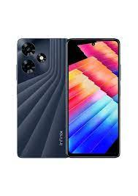

Infinix Hot 30 ; **Size, 6.78 inches, 109.2 cm2** (~84.5% screen-to-body ratio) ; Resolution, 1080 x 2460 pixels (~396 ppi density) ; OS, Android 13, XOS 12.6 ; Chipset ...

**PRICE /** 32,900 **PRK**